Assessment Schedule – 2014

Calculus: Apply differentiation methods in solving problems (91578)

Evidence Statement
Q1 | Expected Coverage | Achievement  u | Merit  r | Excellence  t
(a) | 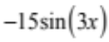 | A correct expression for the derivative.
(b) | 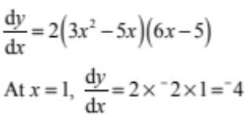  Gradient of normal 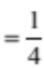 through (1,4) | A correct solution.
(c) | 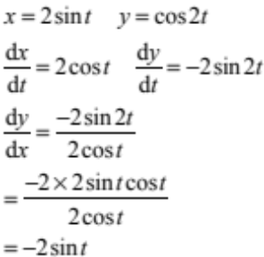 | Correct expressions for 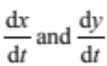. | A correct solution.
(d) | 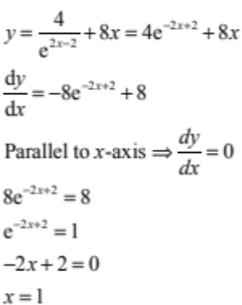 | A correct expression for 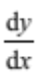. | A correct solution.
(e) | 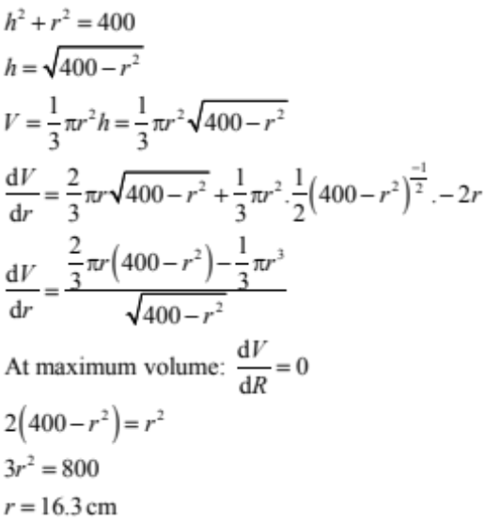  V = 3225 cm³  Alternative working:  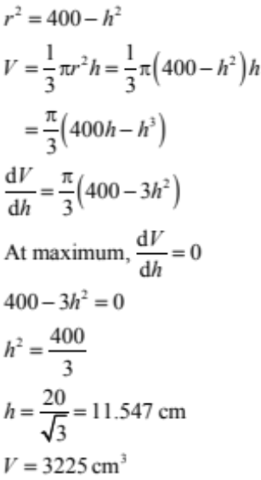 | Correct derivative for an incorrect but relevant expression for V. | A correct expression for 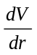. | A correct solution.  Units not required.

NØ | N1 | N2 | A3 | A4 | M5 | M6 | E7 | E8
No response; no relevant evidence. | ONE answer demonstrating limited knowledge of differentiation techniques. | ONE correct derivative | 2u | 3u | 1r | 2r | 1t with minor error(s). | 1t

Q2 | Expected Coverage | Achievement  u | Merit  r | Excellence  t
(a) | 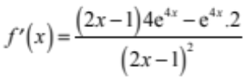 | A correct expression for the derivative.
(b) | 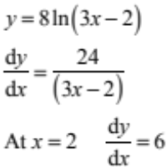 | A correct solution.
(c)(i)  (ii)  (iii) | 1. –2, –1, 2  2.  3. –2  4  3 | 2 correct answers | 4 correct answers.
(d) | 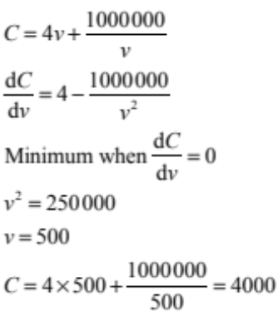 | Correct value for v with correct derivative. | A correct solution.  Units not required.

(e) | 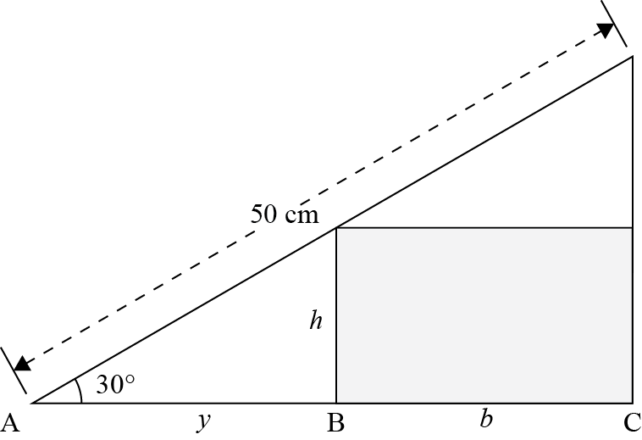  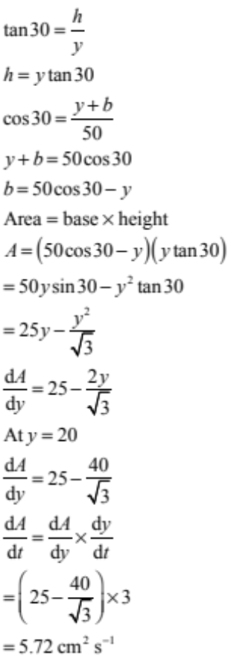 | Correct derivative for an incorrect but relevant expression for A. | A correct expression for 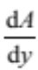 | A correct solution.  Units not  Required.

NØ | N1 | N2 | A3 | A4 | M5 | M6 | E7 | E8
No response; no relevant evidence. | ONE answer demonstrating limited knowledge of differentiation techniques. | ONE correct derivative | 2u | 3u | 1r | 2r | 1t with minor error(s). | 1t

Q3 | Expected Coverage | Achievement  u | Merit  r | Excellence  t
(a) | 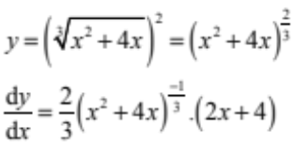 | A correct expression for the derivative.
(b) | 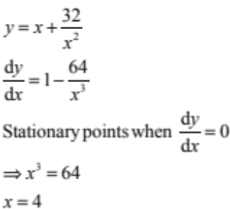 | A correct solution.
(c) | 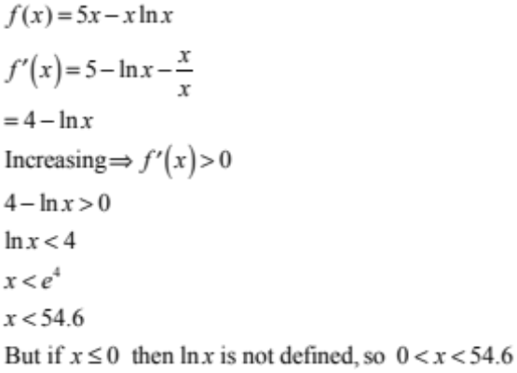 | A correct expression for the derivative. | A correct solution.
(d) | 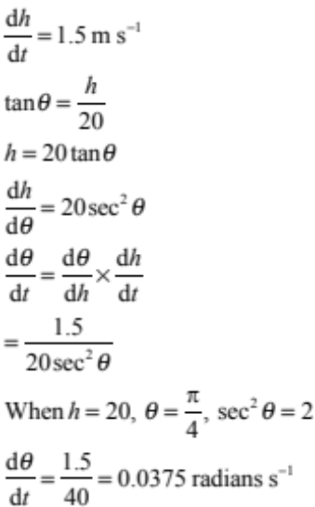 | A correct expression for 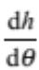 | A correct solution.  Units not required.

(e) | 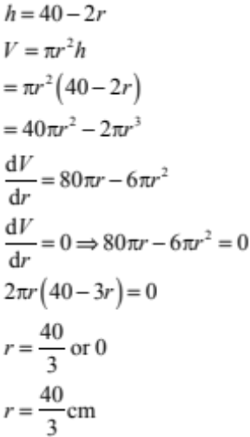 | Correct derivative for an incorrect but relevant expression for V. | A correct expression for 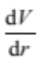 | A correct solution.  Units not required.

NØ | N1 | N2 | A3 | A4 | M5 | M6 | E7 | E8
No response; no relevant evidence. | ONE answer demonstrating limited knowledge of differentiation techniques. | ONE correct derivative | 2u | 3u | 1r | 2r | 1t with minor error(s). | 1t

Cut Scores
 | Not Achieved | Achievement | Achievement with Merit | Achievement with Excellence
Score range | 0 – 7 | 8 – 12 | 13 – 20 | 21 – 24

Marking codes

Codes that may have been used in marking this examination paper have meaning as follows.

# Hash - where a candidate obtains a correct answer but continues with further, unnecessary, material that is incorrect but does not show a lack of understanding or a contradiction.

C Consistency - where a candidate has obtained an incorrect value within a question and subsequently uses that value.

NC Non-consistency - where a candidate has obtained an incorrect value or expression within a question and does not use that value or expression where it is subsequently required.

RAWW Right answer, wrong working - where a candidate presents a correct answer but the working or reasoning leading to it is irrelevant, incomplete or contains one or more errors.

R Rounding error - where a candidate produces a correct sequence of calculations, but the answer does not agree to 2 significant figures with the answer given in the assessment schedule as a result of rounding a number in the sequence of calculations.

mei Minor error ignored - where a candidate make a minor error and this has been ignored.

Two ans Two answers given - where a candidate writes two answers, one correct and the other incorrect, and neither has been deleted (the correct answer is not accepted).

